Name: Yehuda Gurovich I.D.: 44184491 בס”ד

Date: 5/5/2024

**Advanced Computer Networks – רשתות מחשבים מתקדם**

**Laboratory 01 - Wireshark Exercise:**

Image for 1-3:

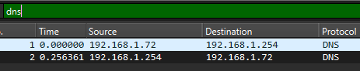

1. **What is the IP address of the DNS/HTTP client in the trace file *wwb001-http.pcapng*?**

192.168.1.72

1. **What is the IP address of the DNS server?**

192.168.1.254

1. **What DNS response time is seen in the trace file?**

0.256361 seconds

1. **Do you think that this trace was taken (captured) closer to the HTTP client or closer to the HTTP server?**

Closer to the server. We can see in time from previous packet mode that the time between 2 packets from same source to destination is generally smaller in the server.

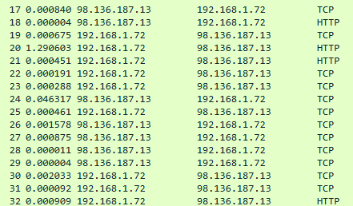

**Homework:**

1. **What are the IP addresses of the HTTP servers to which the client successfully connected?**

* 98.136.187.13
* 98.139.206.151

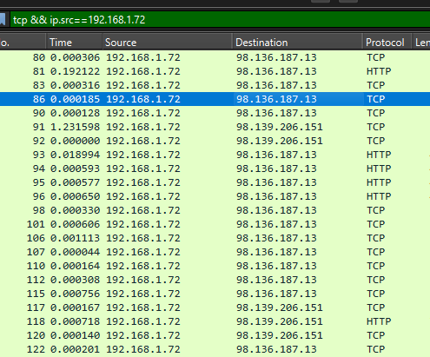

We see the 2 different destination addresses.

1. **What are the HTTP host names of the target HTTP servers?**

* http://www.wiresharktraining.com/
* http://visit.webhosting.yahoo.com/visit.gif?&r=&b=Netscape%205.0%20%28Windows%20NT%206.1%3B%20WOW64%3B%20Trident/7.0%3B%20SLCC2%3B%20.NET%20CLR%202.0.50727%3B%20.NET%20CLR%203.5.30729%3B%20.NET%20CLR%203.0.307]

Checking the HTTP packets from the 2 different sources in question 5 we obtain these 2 host names.

1. **How many TCP SYN packets did the client send to the HTTP servers?**

8

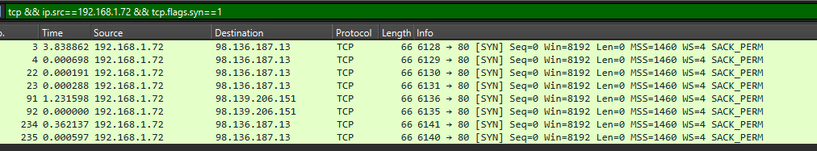

1. **What Uniform Resource Identifier (URI) does the client request first in this trace file?**

<http://www.wiresharktraining.com/>

1. **What HTTP error response(s) are seen in this trace file?**

* 200 OK
* 404 Not Found

1. **What requested web object could not be found on the HTTP server?**

As we see in the bottom of the image in question 9 we see the GET request to <http://www.wiresharktraining.com/favicon.ico> gets a response of 404 Not Found

1. **What TCP port numbers did the client open to communicate with the HTTP server?**

* 6128
* 6129
* 6130
* 6131
* 6136
* 6140

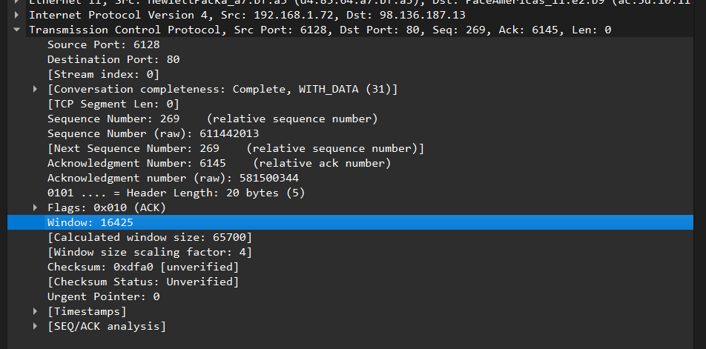

We go over all the TCP packets where the source is the client and check the different opened ports

1. **What TCP options are supported by the client?**

* MSS
* Window scale
* SACK permitted

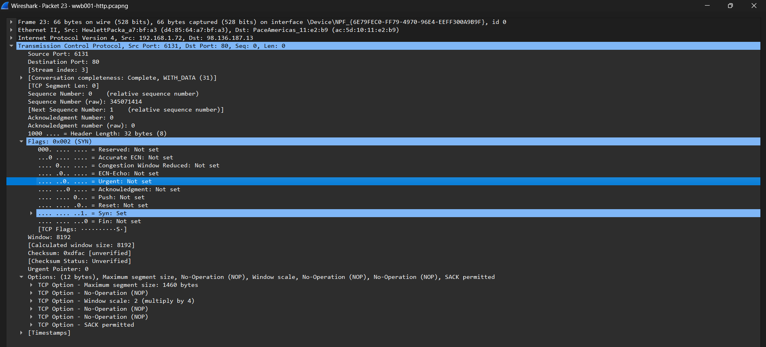

We see at the bottom the options that are available.

1. **What words are seen in the featureb.jpg image?**

Get Deep



1. **What is the average throughput rate (bits per second) in this trace file?**

4560 bits/second as we see in the graph below the throughput just before the end.

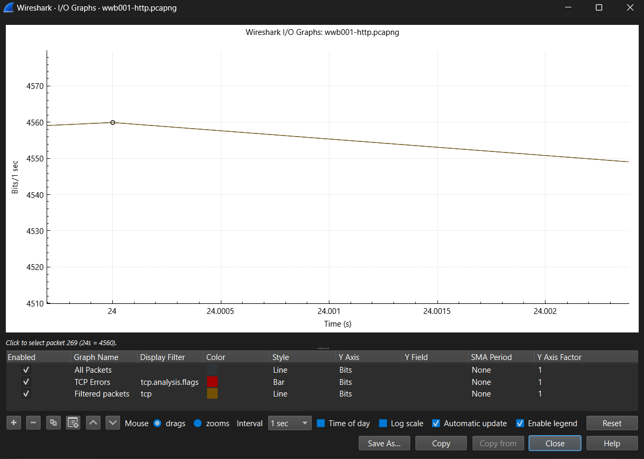

1. **How many UDP streams are in the trace file?**

0 because there are no handshakes established with UDP protocol

1. **What is the purpose of TCP stream 7?**

It’s a GET request to <http://www.wiresharktraining.com/favicon.ico> but it gets a response HTTP message of 404 Not Found

1. **How many times does the packets per second rate reach over 125 in this trace file?**

1 time. We can see that in the graph below that the 125 packets/s gets crossed only once.

